Week 3 network labs
Measuring circuit 1: measuring voltages with a multimeter
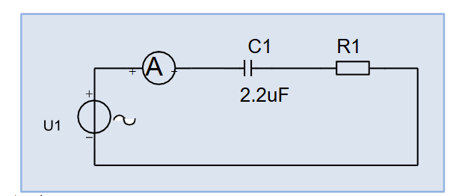
Use the following values:
R1=470 ohm C1=2.2μF

A0. Measure with an AC meter: U1, UC1 and UR1, and read the AC meter . A1. Do these
measurement data match Kirchhoff's voltage law? Check that you have not made any
measurement errors.
U1 = 29.12 V
UC1=27.66 V I = 19.11 mA
UR1=8.81 V I = 18.74 mA
KVL:
U1^2 = UC1^2+UR1^2
UC1^2+UR1^2 =764.4+77.6=842.0
U1^2 = (29.12)^2 = 848.0
848-842 = 6 this is minimal difference less than 1 percent it matches what we expected.

A1.

Measuring circuit 2: Measuring current with the oscilloscope
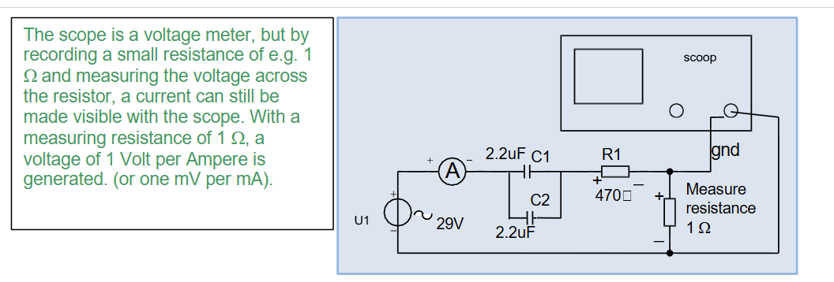
B0.
Ieff() | Imax() | Idmm() | T()
36,7mV | 52mV | 108mV | 20.000 ms

B1.
F=1/T = 1/0,05 = 50HZ
B2. Reactance for capacitors formula = 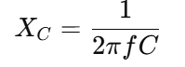
R1 = 470 Ω
XC1,2 = 1/2pi(50)(2,2x10^-6) = 1447 Ω
Ceq = C1+C2 = 4,4 x10^-6
XCeq = = 1/2pi(50)(4,4x10^-6) = 723.5 Ω
Total impedance with R1 :
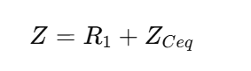
Zceq = −j723.5 Ω
|Z| = square root of (470^2+723,5^2) = 863 Ω
B4. (next page)
Current formula is 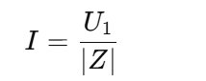
I = 29.12/863 = 0,003374 A = 33,74mA
The multi meter is similar.
B5.

